VLOOKUP function
Applies To: Excel 2016 Excel 2013 Excel 2010 Excel 2007 Excel 2016 for Mac More...
Use VLOOKUP, one of the lookup and reference functions, when you need to find things in a table or a range by row. For example, look up a price of an automotive part by the part number.
In its simplest form, the VLOOKUP function says:
=VLOOKUP(Value you want to look up, range where you want to lookup the value, the column number in the range containing the return value, Exact Match or Approximate Match – indicated as 0/FALSE or 1/TRUE).
This video is part of a training course called VLOOKUP: When and how to use it.
TIP: The secret to VLOOKUP is to organize your data so that the value you look up (part number) is to the left of the return value you want to find (price of the part).

Technical details

How to get started
There are four pieces of information that you will need in order to build the VLOOKUP syntax:
- The value you want to look up, also called the lookup value.
- The range where the lookup value is located. Remember that the lookup value should always be in the first column in the range for VLOOKUP to work correctly. For example, if your lookup value is in cell C2 then your range should start with C.
- The column number in the range that contains the return value. For example, if you specify B2: D11 as the range, you should count B as the first column, C as the second, and so on.
- Optionally, you can specify TRUE if you want an approximate match or FALSE if you want an exact match of the return value. If you don't specify anything, the default value will always be TRUE or approximate match.
Now put all of the above together as follows:
=VLOOKUP(lookup value, range containing the lookup value, the column number in the range containing the return value, optionally specify TRUE for approximate match or FALSE for an exact match).
The following picture shows how you'd set up your VLOOKUP to return the price of Brake rotors, which is 85.73.
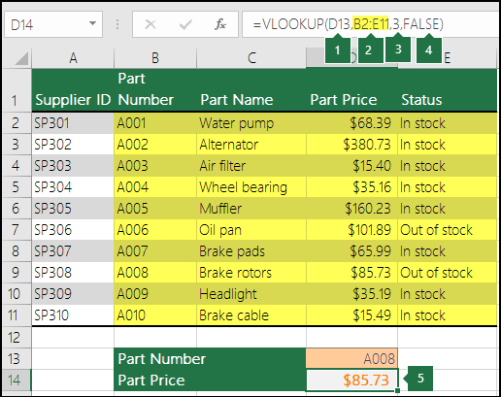
- D13 is lookup_value, or the value you want to look up.
- B2 to E11 (highlighted in yellow in the table) is table_array, or the range where the lookup value is located.
- 3 is col_index_num, or the column number in table_array that contains the return value. In this example, the third column in the table array is Part Price, so the formula output will be a value from the Part Price column.
- FALSE is range_lookup, so the return value will be an exact match.
- Output of the VLOOKUP formula is 85.73, the price of Brake rotors.

