Tone of voice

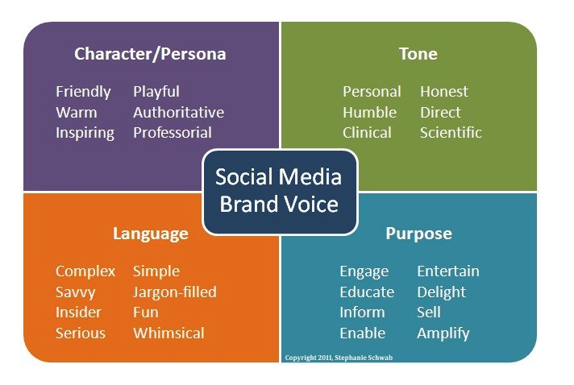

The three C’s of brand voice
You can start developing a voice for your brand by examining your culture, community, and conversation.
Culture – What does your company stand for? What makes you stand out from all the others who are after the same audience? Your unique qualities make your culture special, and these should be a pillar of developing your voice.
Community – Listening can reveal how your community speaks and can help you speak easier with them and to them. You can use their language and meet them on their terms.
Conversation – Personality and authenticity are key here. What do you want to add to the conversation? As you think about what you can offer, you’ll start to see a better picture of where your voice might fit.

Ask the right questions
Once you have your bearings on the direction you’re headed, thanks to an overview with the three C’s of brand voice, next it’s time to start gathering information and details. A great place to start is asking questions.
- If your brand were a person, what kind of personality would it have?
- If your brand was a person, what’s their relationship to the consumer? (a mentor, friend, thought leader)
- Describe in adjectives what your company’s personality is not.
- Are there any companies that have a similar personality to yours? Why are they similar?
- How do you want your customers to think about your company?

