A Guide to LinkedIn

Why LinkedIn?

A LinkedIn company page helps you network and prospect for quality sales leads, but it also establishes your public image on a global scale as a reputable and trustworthy organization.

Although the view of many consumers is social media site LinkedIn purely as a site for job hunters and the growth of personal networks,

LinkedIn is an equally effective tool for generating new business.

A 2013 study revealed that 84% of users generated several business opportunities from the use of LinkedIn.

By creating a LinkedIn company page you can start to encourage sales prospects to make contact with your company and build a community that can work with the brand.

- Creating shareable content. By producing content that that the community wants to read and share your LinkedIn fee becomes an essential ‘hub’ for sharing blogs, case studies, infographics, videos, webinars and product information. By commenting on the latest industry news, the LinkedIn feed can also highlight to the readers that you aware of emerging trends.

- A sounding board. As a company, you can utilise LinkedIn as a platform that can help introduce new products and services available to those new to the company. Ensure that you include as many external links as possible to help with the SEO factor of then bringing traffic to your main website.

- Think about your competitors. On LinkedIn, it can be a very simple platform to highlight why you stand our and differentiate from your competitors. People like familiarity – it is what keeps them loyal and engaged. Ensure that you have a ‘non-salesy’ voice. Also, use LinkedIn as a platform to ‘spy’ on competitors and use it as a way of making internal improvements.

- An essential tool for SEO. One of the essential benefits for a company is ensuring that they optimize their SEO. SEO stand for ‘search engine optimization’ and is the process on generating free, organic, editorial, and natural traffic to search engine results on search engines.

All major search engines such as Google, Bing and Yahoo have primary search results, where pages and other content such as videos or local listings are shown and ranked on what the search engine considers most relevant to users. Search engine rank LinkedIn company pages, so ensuring that the pages are posting updates will help improve the search engine results and help build awareness for people search on search engines for key terms related to your company.

- Live long and prosper. Once you have set up a good quality LinkedIn company page the value will be building up the brand awareness and enhancing sales growth. Sales teams can utilise the platform as a lead finder opportunity and marketing team can ensure that their message is being transmitted through a new and separate platform from existing data-list (that may be out-of-date).

How to start a company page:

A Company Page helps others learn more about your business, brand, products and services, and job opportunities. You can create one from the Add a Company page.

Note: Before starting, you must own a personal LinkedIn profile set up with your true first and last name. Also, make sure you meet our requirements to add a Company Page and that your current company doesn't already have one.

To add a Company Page:

Move your cursor over Interests at the top of your homepage and select Companies.

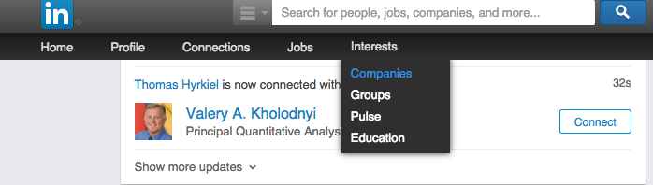

Click Create in the Create a Company Page box on the right.

Enter your company's official name and your work email address.

Click Continue and enter your company information.

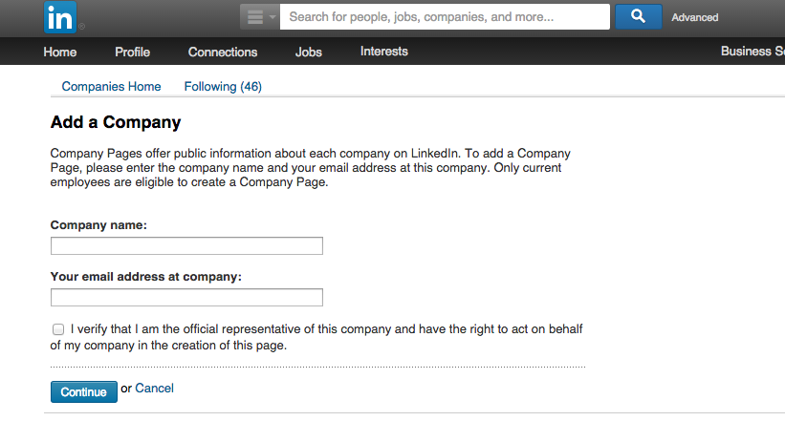

If the work email address you provide is an unconfirmed email address on your LinkedIn account, a message will be sent to that address. Follow the instructions in the message to confirm your email address, and then use the instructions above to add the Company Page.

In a nutshell:

