PowerPoint The Basics

Choose a theme
When you open PowerPoint, you’ll see some built-in themes and templates. A theme is a slide design that contains matching colours, fonts, and special effects like shadows, reflections, and more.
- Choose a theme.
- Click Create, or pick a colour variation and then click Create.
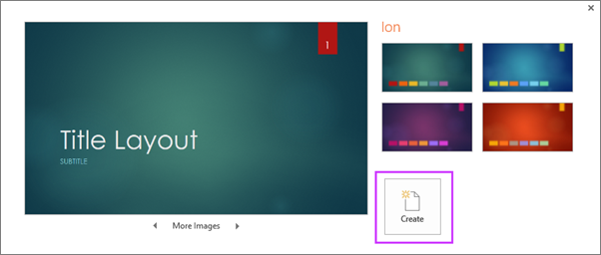
Read more: Apply colour and design to my slides (theme)

Insert a new slide
- On the Home tab, click the bottom half of New Slide, and pick a slide layout.
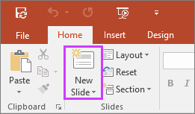
Read more: Add, rearrange, and delete slides.

Save your presentation
- On the File tab, choose Save.
- Pick or browse to a folder.
- In the File name box, type a name for your presentation, and then choose Save.
NOTE: If you frequently save files to a certain folder, you can ‘pin’ the path so that it is always available (as shown below).
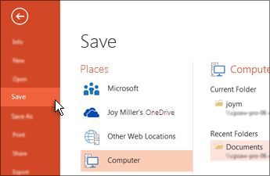
TIP: Save your work as you go. Hit Ctrl+S often.
Read more: Save your presentation

Add text
Select a text placeholder, and begin typing.
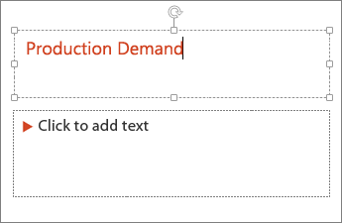

Format your text
- Select the text.
- Under Drawing Tools, choose Format.
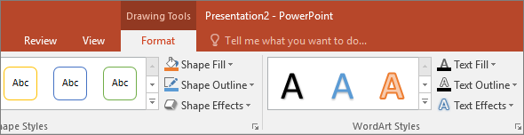
- Do one of the following:
- To change the colour of your text, choose Text Fill, and then choose a colour.
- To change the outline colour of your text, choose Text Outline, and then choose a colour.
- To apply a shadow, reflection, glow, bevel, 3-D rotation, a transform, choose Text Effects, and then choose the effect you want.

Change the fonts
Applies To: PowerPoint 2016 PowerPoint 2013 PowerPoint Online
You can change the fonts on a single slide, or you can change the fonts throughout your presentation. And if you want to use fonts not available in PowerPoint, see Use decorative fonts from third-party vendors.
When you use a font that is not installed with the current Windows operating system, you may get an error message, or some people you share the presentation with may not see the font. One way to avoid this problem is to embed the font in your presentation (File > Options > Save > Embed fonts in the file). Another solution is to replace the problematic font, as described in this article.

Change the fonts on a single slide
- Do one of the following:
  - To change the font for a single paragraph or a phrase, select the text that you want to change.
  - To change the font for all the text in a placeholder, either select all the text in the placeholder, or click the placeholder.
- On the Home tab, in the Font group, select a font in the Font list.

Change the fonts throughout your presentation
NOTE: This functionality is not available for PowerPoint Online.
If you’re using one slide master, and you change a font on the slide master, the new font will appear throughout your presentation.
If you’re using multiple slide masters (for example, when you apply more than one template to your presentation), you must change the font style on each slide master.
- On the View tab, in the Master Views group, click Slide Master.
- In the left pane that contains the slide masters and layouts, click the slide master thumbnail or layout that contains the font that you want to change.
- On the slide master or layout, click the title text or the level of body text that you want to apply a new font style to.
- On the Slide Master tab, in the Background group, click Fonts, and then select a font from the list.
Repeat steps 1 through 4 for any other fonts that you want to change. To return to editing your slides, on the Slide Master tab, in the Close group, click Close Master View.
You can also go to Replace Fonts to change a font throughout your presentation. Here's how:
- In the Editing group, select Replace and then select Replace Fonts.
- In the Replace Font dialog, in the Replace field, select the font that you want to replace.
- In the With field, select the font that you want to use, select Replace, and then select Close.

To change the colour of text on a slide
- Select the text that you want to change.
- On the Home tab, choose Font Colour, and then select the colour that you want to change the colour of the text to.
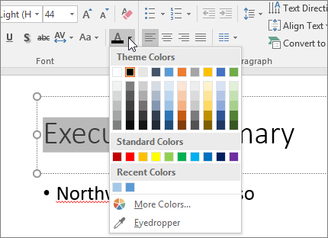
TIPS:
- If you don’t see the colour that you want, choose More Colours, and then select a colour on the Standard tab, or mix your own colour on the Custom tab.
- Choose Eyedropper to match colours on your slide. As you move your mouse over other text colours, a live preview of the colour appears in a square. Select the colour you want to match to apply it to the selected text. The eyedropper tool is not available in PowerPoint 2007.

To change the colour of text on multiple slides
Changing the text colour on the slide master applies the changes to text on multiple slides at one time.
- On the View tab, choose Slide Master.
- In the left thumbnail pane, select a layout that contains the text you want to change to a different colour.
- Select the text on the layout that you want to change.
- On the mini toolbar that appears, choose Font Colour, and then select the colour you want to change the colour of the text to.
TIP: If you don’t see the colour that you want, choose More Colours, and then select a colour on the Standard tab, or mix your own colour on the Custom tab.
- When you’re finished, choose Close Master View to return to your presentation.
TIP: If you’re building a presentation with many slides, it helps to create the slide master first (see Create and save a PowerPoint template for more information. That sets the text colour and other design styles ahead of time, and each new slide you create comes with the text colour that you want.

Add bullets or numbers to text
Applies To: PowerPoint 2016 PowerPoint 2013
You can use bullets or numbers to help organize your text or show a sequential process in your PowerPoint presentation.
2016, 201320102007

Add bullets or numbers to text in PowerPoint 2016 or 2013
- On the View tab, in the Presentation Views group, click Normal.
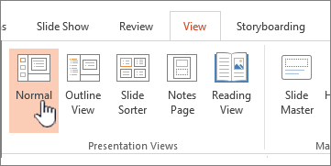
- On the left-hand side of the PowerPoint window, click a slide thumbnail that you want to add bulleted or numbered text to.
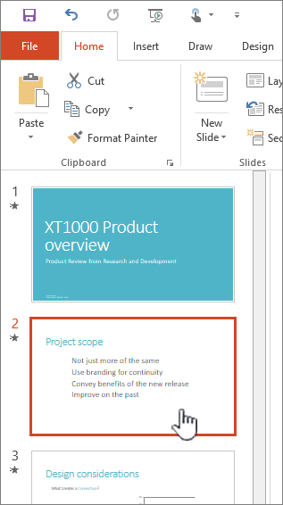
- On the slide, select the lines of text in a text placeholder or table that you want to add bullets or numbering to.
- On the Home tab, in the Paragraph group, click Bullets or Numbering .
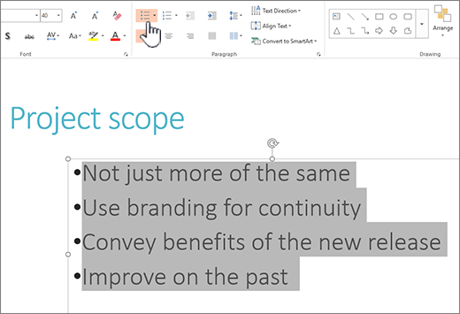
NOTES:
  - To change all lines of text, select the outline of the text object, and then apply the bullet or numbering.
  - To increase or decrease the indent, to change spacing between a bullet or number and the text, to change the style, colour, or size of bullets or numbers, to manually change the number that you want to start from, and so on, see Adjust the indent in a bulleted or numbered list.

Learn how to change the colour and style of bullets, and understand the limitations
For much more about formatting and customizing lists in PowerPoint, see Change the colour and style of a bulleted or numbered list.

I'm only seeing a single bullet, no matter how many lines I add
Check to make sure you're putting bullets or numbers in a Text box, and not a Title box. In a Text box, you get a number or bullet every time you press Enter. If you press CTRL + Enter, you get additional lines without bullets (good for details or notes on a bulleted or numbered line).
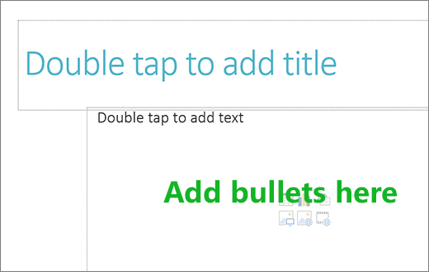
In a Title box, the text is expected to be a single line heading or title. You can use numbers or bullets, but it treats all lines of text as a single line, resulting in a single bullet or number.

How do I stop having bullets every time I add a line?
To stop creating bullets or numbers and return to text, click Bullets or Numbering again to turn it off.
You can also press Enter and then press Backspace to erase the bullet or number. You can then start adding text, or press Enter to add extra empty lines.

How do I do multi-level bulleting?
To create a multi-level list, click Increase Indent to make an indented line. To go back a level, click Decrease Indent .
For more info, see Change the colour and style of a bulleted or numbered list.

How do I change the default bullets to another symbol?
To change the default bullets, follow these steps.
- On the View tab, click Slide Master.
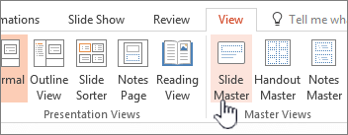
- Select the Master slide (the first, larger slide, in the thumbnail panel).
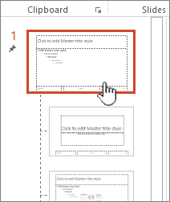
- Click the Home tab.
- Select one or more of the bulleted lines in the samples.
- Click the down arrow on the Bullet button, and choose the style you want for a default.
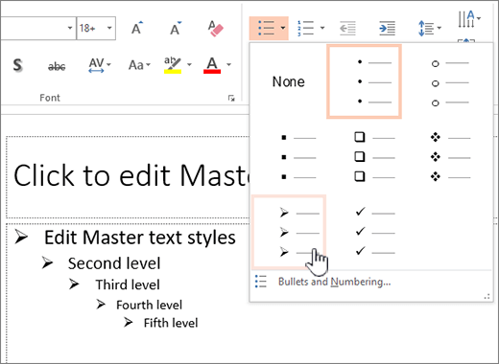
- Repeat if you have different bullets for different lines.
- When you're done updating the bullet styles, click the Slide Master tab, and then click Close Master View.

Format text as superscript or subscript
Applies To: PowerPoint 2016 PowerPoint 2013 PowerPoint 2010 PowerPoint 2007
A subscript or superscript is a number, figure, symbol, or indicator that is smaller than the normal line of type and is set slightly below (subscript) or above it (superscript).

Apply superscript or subscript formatting to text
- Select the text that you want to format as superscript or subscript.
- On the Home tab, in the Font group, pick the Dialog Box Launcher.
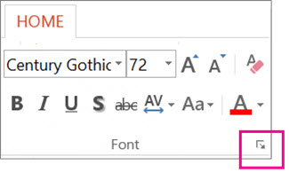
- On the Font tab, under Effects, select the Superscript or Subscript check box.
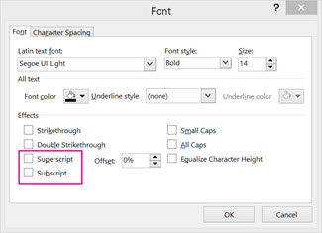
TIP: You can make text superscript or subscript without changing the font size. For superscript, enter a higher percentage in the Offset box. For subscript, enter a lower percentage in the Offset box.

Insert a superscript or subscript symbol
- On the slide, click where you want to add the symbol.
- On the Insert tab, click Symbol.
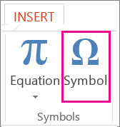
- In the Symbol box, in the Font drop-down list, select (normal text) if it isn't already selected.
- In the Symbol box, in the Subset drop-down list, select Superscripts and Subscripts.
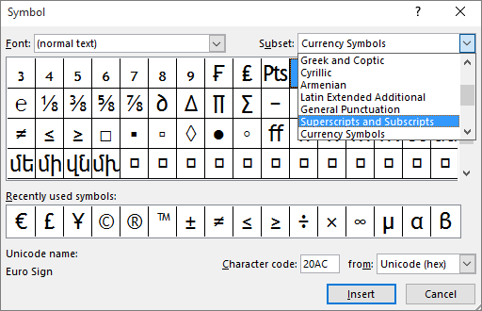
- In the Symbol box, select the symbol you want, press Insert, and then pick Close.

