PLAN - Create a digital marketing strategy

OPPORTUNITY Review marketplace and set objectives Start with these key activities to define your digital opportunity through marketplace analysis:

1. Review digital marketing capabilities
2. Analyse performance using KPI dashboards after customising analytics for your business
3. Summarize customer insight in customer personas and customer journey maps
4. Audit brand and benchmark competitors
5. Review influencer outreach, co-marketing and intermediaries
6. Define *SMART objectives with conversion spreadsheet models to quantify opportunity

*SMART

Once you have planned your project, turn your attention to developing several goals that will enable you to be successful. Goals should be SMART - specific, measurable, agreed upon, realistic and time-based.
A goal might be to hold a weekly project meeting with the key members of your team or to organise and run a continuous test programme throughout the project.
The acronym SMART has several slightly different variations, which can be used to provide a more comprehensive definition of goal setting:
S - specific, significant, stretching
M - measurable, meaningful, motivational
A - agreed upon, attainable, achievable, acceptable, action-oriented
R - realistic, relevant, reasonable, rewarding, results-oriented
T - time-based, time-bound, timely, tangible, trackable

STRATEGY Create digital strategy

Review your digital proposition and communicate it using digital targeting techniques:
☐ Select target market segments and personas. Define digital targeting approaches
☐ Define your online value proposition (OVP) including review of business and revenue model, brand positioning and integration with traditional channels
☐ Review marketing mix for online options for the 4Ps - Product, Price, Promotion and Place ACTION Implement and manage digital marketing communications Make smart budget investments and optimise your digital communications across 25 key customer touchpoint interactions covered by:
☐ Reach: Build your audience by integrating paid, owned and earned media
☐ Act: Using content marketing and persuasion to prompt brand interaction and leads
☐ Convert: Use conversion rate optimization to boost online and offline sales
☐ Engage: Develop customer loyalty and repeat sales

REACH
Grow your audience online

GROWING REACH Reach involves building awareness of your brand, products and services on other websites and in offline media to build traffic to different web presences like your main site, microsites or social media pages. It involves maximising reach using continuous inbound communications and planned campaigns to create multiple interactions using different paid, owned and earned media touchpoints.

OPPORTUNITY Define your online audience potential Set realistic targets for building traffic, awareness and social media followers

☐ Define KPI dashboards to review effectiveness of current digital media in analytics
☐ Review current use of digital media and opportunities to improve ☐ Set VQVC (volume, quality, value, cost) objectives using conversion budget models STRATEGY Select the best communications options Your online customer acquisition strategy should:
☐ Define key brand messages to grow audience awareness, familiarity and purchase intent
☐ Select relevant media and targeting
☐ Link to your content marketing strategy (Act)
☐ Prioritise channel media spend, summarized in a conversion-based media plan and budget ACTION Optimise your digital communications Work on optimising content marketing to support key digital communications for your business:
☐ PR, influencer outreach and SEO
☐ Optimize Google AdWords (paid search)
☐ Review opportunities from Display Advertising
☐ Review relevance of affiliate and partner marketing
☐ Social media marketing optimization

KPIs – Step 1

Define your key purpose. What are the 2-3 major goals your organisation is working towards? Place these at the top of your plan, in clear view at all times.

Step 2

Plot your digital objectives.

Refer to your digital plan if you need to.

Add your primary and secondary objectives to
the table.

Step 3

Add your actionable goals. How will you reach your objectives, what actionable goals will help you? Can you include any anecdotal metrics?

Step 4

Determine your metrics.

What metrics are you going to measure – number of views? number of clicks?

Making sure it’s a number or percentage rate, add them to the table.

Step 5

Set your targets.

Use your previous data as a guide for setting
benchmarks.

Be realistic about what you can deliver.

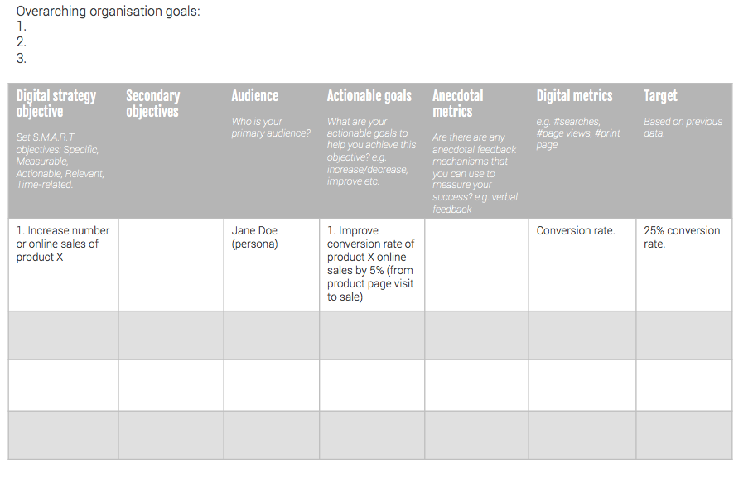

ACT Encourage brand interactions and leads

INCREASING INTERACTIONS

Act is short for Interact. It’s a separate stage from conversion since encouraging interactions on websites and in social media to generate leads is a big challenge for online marketers. It’s about persuading site visitors or prospects to take the next step, the next Action on their journey when they reach your site or social network presence.

OPPORTUNITY Identify best options to increase lead conversion ☐ Review customer journeys for desktop-mobile visits using analytics and feedback tools
☐ Review social media and mobile marketing platform engagement ☐ Define goals, events and dashboards for measuring customer interactions

STRATEGY Prioritise content marketing and customer journeys ☐ Define customer personas

☐ Define content marketing plan

☐ Create website improvement plan including lead profiling ACTION Manage content marketing and lead generation

☐ Create campaign plan, editorial calendar and outreach plan

☐ Create content assets including video marketing

☐ Improve landing pages and site page templates. Personalised onboarding.

CONVERT Increase sales through

CRO INCREASING CONVERSION This is the conversion from lead to sale. It involves getting your audience to take that vital next step which turns them into paying customers whether the payment is taken through online Ecommerce transactions, or offline channels.

OPPORTUNITY Review focus to increase conversion to sale ☐ Create and review site conversion funnels and paths to purchase (online and offline) and quantify targets for incremental revenue ☐ Review multichannel (omni-channel) interactions to increase revenue per visit ☐ Review analytics and customer feedback

STRATEGY Create an approach for conversion rate optimisation ☐ Define online conversion rate optimisation (CRO) approach ☐ Define how key online communications (search, email, social, mobile) drive sales ☐ Define offline integration paths to purchase

ACTION Manage continuous improvement of conversion ☐ Implement CRO through test plan for AB and multivariate site tests and experiments
☐ Implement lead retargeting programme using site personalization, display retargeting and behavioural email programme
☐ Optimise ROPO behaviour (Research Online-Purchase Offline)
ENGAGE Build customer loyalty and advocacy

IMPROVING CUSTOMER ENGAGEMENT

This is long-term engagement that is, developing a relationship with first-time buyers to build customer loyalty as repeat purchases using communications on your site, social presence, email and direct interaction. We’re also looking to build advocacy or recommendations through ‘word-of-mouth’.

OPPORTUNITY Review potential to increase customer activity levels

☐ Review customer loyalty using RFM analysis for interactions and sales. Quantify incremental revenue potential

☐ Review customer satisfaction drivers

☐ Review effectiveness of customer communications STRATEGY Define plan to improve customer retention and engagement

☐ Create customer engagement plan

☐ Create online personalisation and merchandising plan for incremental revenue

☐ Create customer contact plan (email marketing and social media marketing) ACTION Implement online customer communications plan

☐ Implement or refine personalization rules on desktop and mobile sites

☐ Customer onboarding including event-triggered personalized emails and enewsletters

☐ Manage social media and email campaigns for customer engagement and advocacy

