Keywords are the words or groups of words ('terms') that someone types in when they want to find information on a search engine like Google. They’re also what triggers your ad to show up in relevant search results if you’re running pay-per-click advertising with Google AdWords.
Basing your AdWords campaign and strategy on quality keywords is beneficial to both your business and potential customers: they’re connected with businesses who offer what they want the moment they’re searching for it, and your advertising budget is spent only people who might be interested in visiting, calling, or buying from you.
That’s why it’s so important to find the right keywords for your advertising campaign. The Keyword Planner , a free-to-use tool within AdWords, can help you to discover new keywords potential customers might be likely to use to search for businesses like yours. The tool gives you Google-recommended keywords generated by:
- Keyword: Type in words or phrases relevant to your business or website to get ideas for keywords that you may not have considered before.
- Landing Page: Enter a specific page on your website and the tool will read the page and generate relevant keywords.
- Product Category: Select the product categories that best describe your business to discover popular keywords being used by people searching for products or services like yours.

https://adwords.google.com - please note you will need a GMAIL account
The hover your mouse over to the ‘spanner’ icon and select ‘Keyword Planner’
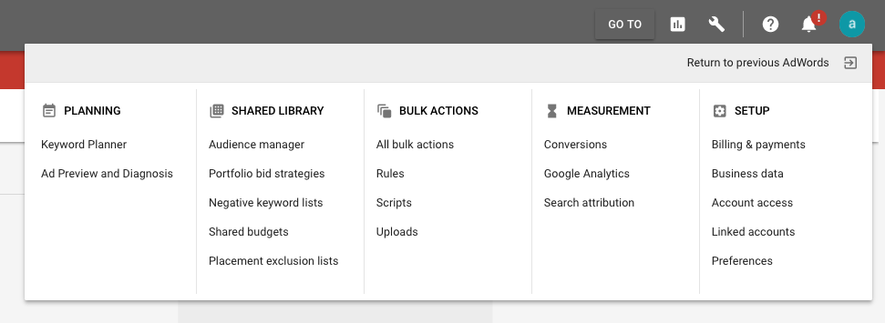

Either type in ‘Your prduct or service’ add in ‘Your Landing Page’ or select ‘Your product Category.
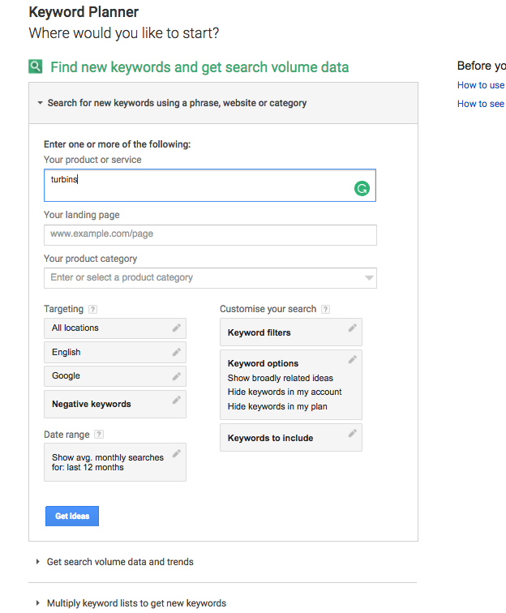

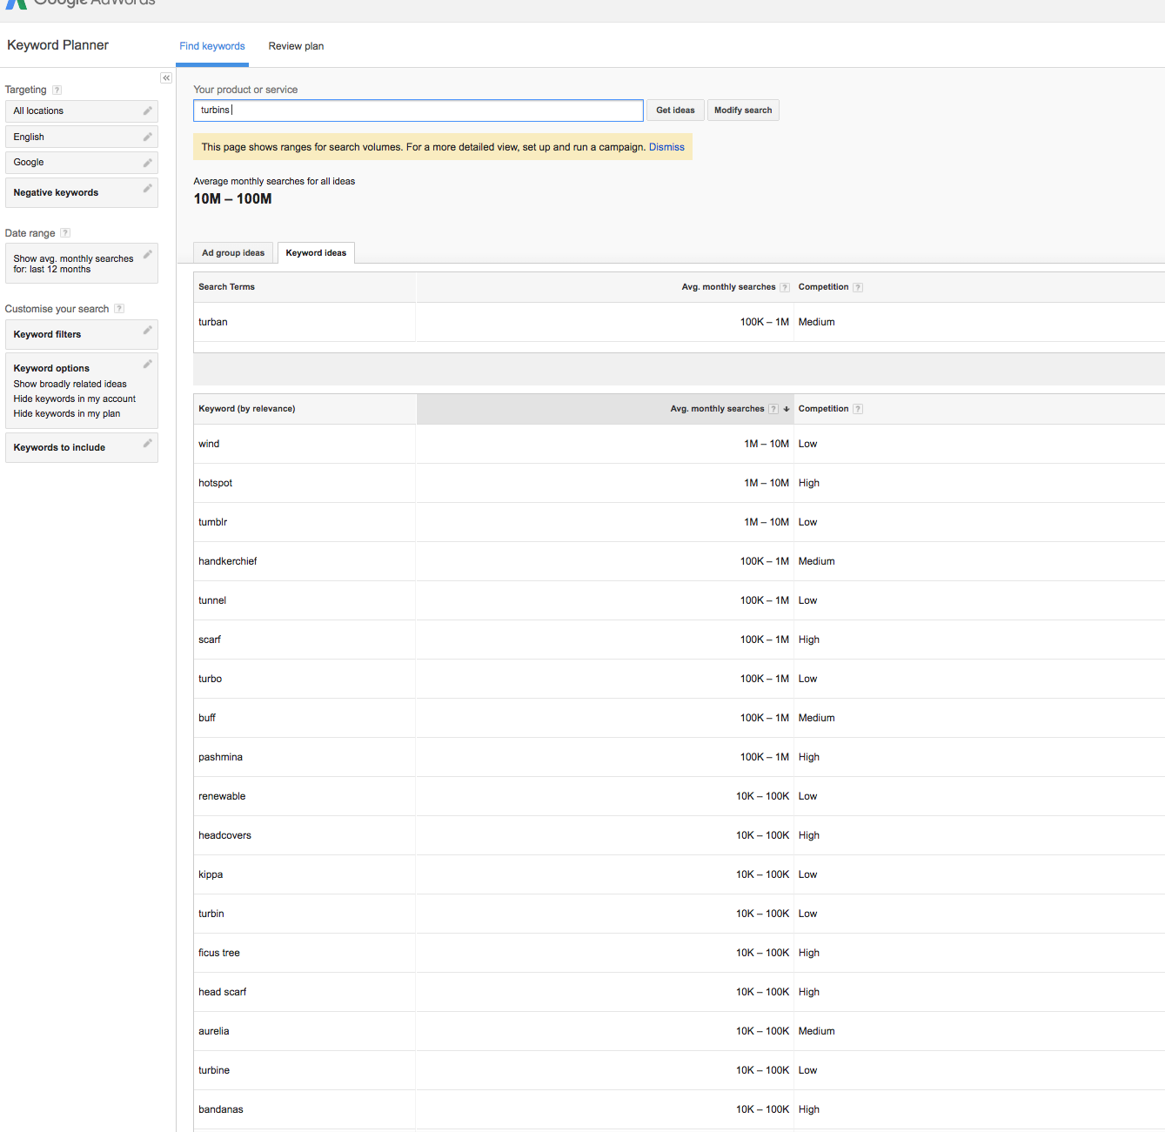
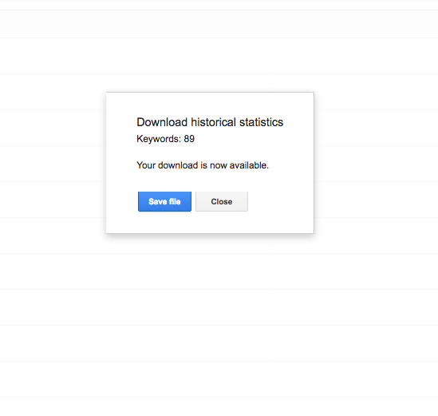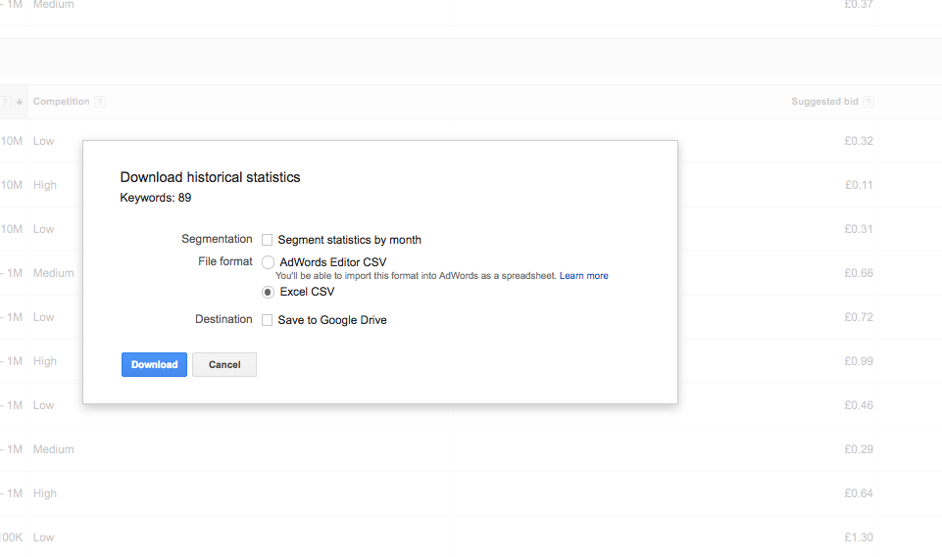

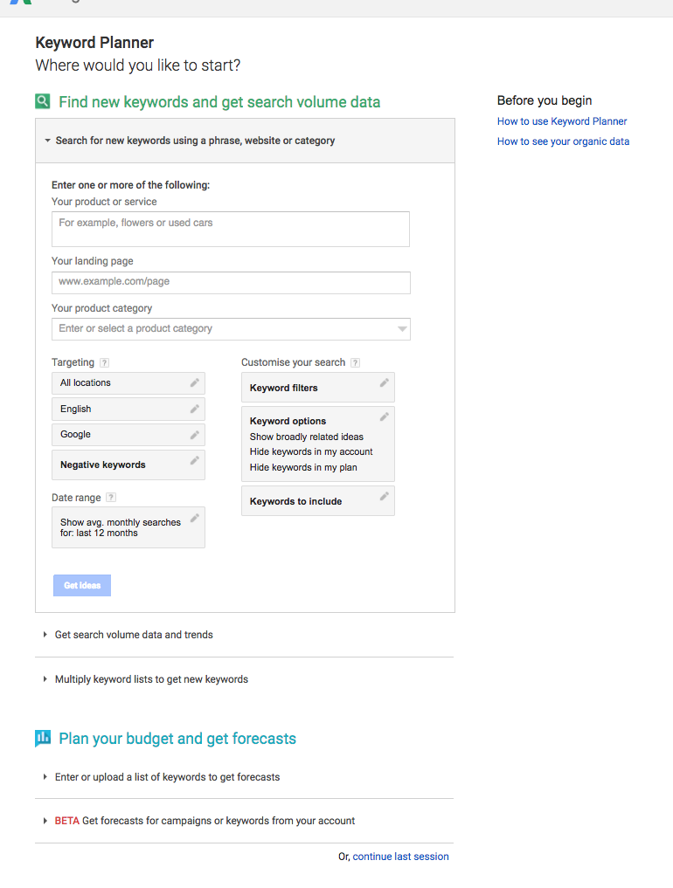

The Keyword Planner can also show you how keywords that you’re considering might perform, in terms of how frequently they’re likely to be used in searches, etc., and offer suggestions about how you might spend your budget on keywords when setting up your campaign. Ready to learn more?
How does the Keyword Planner work?
First, let’s take a moment to understand how keywords are related to your advertising budget. Your budget in AdWords in spent on bidding for keywords, giving you a chance to show up in results. A ‘bid’ is the amount from your budget that you’d be willing to pay to have your ad show up in results when someone searches using a keyword you’ve chosen. The higher your bid, the more likely it might be that your ad shows up. (It also depends on what other businesses have bid for the same keyword).
For example, let’s say that you run a business in the Peak District selling locally-produced honey. The AdWords Keyword Planner can help you to identify keywords and terms related to your business that potential customers are searching for. You may be bidding for the phrase 'Peak District honey' and 'locally produced honey', but the AdWords Keyword Tool might uncover popular, frequently-searched terms that you hadn’t thought of, like 'specialty honey', 'breakfast gift items', etc. that would be good for you to include to potentially draw more visitors to your website or shop.
There are obviously many variations and combinations of words and terms that people might search with that could describe your business, no matter what it is. But the secret to success isn’t to just bid on as many keywords as possible. Quality keywords are more important than a quantity of them – and the Keyword Planner can help you to identify quality on a few different levels, for different purposes.
Check out these tips on how to use the Keyword Planner to help your ad find its way to a potential customer’s search the moment that they want what you offer.
1. Use basic filtering to refine your keyword choices and budget
When you start using the Keyword Planner, you’ll be given four options:
- Search for new keywords: Allows you to type in a phrase, website, or category to generate new keyword ideas.
- Multiple keyword lists: Combines two separate lists that you’ve given to create new keyword combinations.
- Get search volume and trends: Shows the historical trending and search volume for potential keywords.
- Get click and cost performance forecasts: Gives you performance projections for your keyword lists based on the average bids on them and your budget.
When you input keywords into any of these options, you’ll get a list or report, which you can then filter based on these elements, to give you further insight into which keywords might be good for your campaign.
TARGETING
- Location: Gives search volume data and trends based on a specified geographic location or range.
- Language: ives search volume data and trends for a specific language. This can be especially useful if you have multiple language versions or pages on your site.
- Search Network: Changes where the filtered data you see is sourced from. The default data source is Google; however, you may also choose Google and Google Search Partners.
- Negative Keywords: Filters out any words or phrases that you don’t want to see in your results. For instance, if you don’t want to target anything with the words 'cheap' or 'free', this is where you would enter those restrictions.
DATE RANGE
Lets you enter specific date ranges so that you can see average searches for a given time period. You can also compare two different date ranges. This could be especially useful in determining if certain keywords perform better at different times of the year, to help you strategise your campaign timing.
KEYWORD FILTERS
- Average Monthly Searches: Filters keywords based on average monthly searches for selected dates. Keywords with an extremely high search volume (generally 10,000+ average monthly searches) are more difficult to compete for, with a higher suggested bid.
- Suggested Bid: Looks at the costs-per-click (CPCs) that other advertisers are paying for keywords within the same location and Search Network settings that you’ve selected. It then makes suggestions on what you should bid in order to help you to make the most of your budget.
- Ad Impression Share: Estimates how many times people will see your ad, divided by the total number of searches for your exact keyword in the last month for your targeted location and network.
- Organic Impression Share: The percentage of times that a page from your website showed up in a regular, unpaid web search for a particular keyword. (Note: this is only available if you’ve joined your Google Analytics account to your AdWords account.)
- Organic Average Position: hows how pages from your website rank in regular, unpaid searches compared to pages from other websites. (Note: this is only available if you’ve joined your Google Analytics account to your AdWords account.)
- Competition: Lets you filter keywords by how difficult it will be to receive a top position with them. You can filter by high, medium and low difficulty. For small businesses, it's generally recommended to filter for medium to low difficulty, as these tend to have a lower suggested bid so you can make more of your budget.
KEYWORD OPTIONS
Lets you further narrow your research to show only ideas that are closely related to your search terms or content, keywords that are already in your plan, etc.
While the purpose of filters is to help you refine your keyword list or report, you also don’t want to set too many restrictions. A great way to find out how to use the Keyword Planner is to start generally, using just one filter, and then testing each one out to see what ideas are generated before moving on and trying them in combinations. As you become more familiar with popular keywords in your industry and the filtering options available, you’ll start to find out what filter options and combinations work for you.

2. Try targeting your ads to your audience by location
Effective targeting can be especially useful to businesses with a smaller marketing budget, because it allows you to make more strategic choices about how your budget is spent (i.e., on keywords that are more likely to result in visits, calls, sales – whatever your goal is).
This particularly may be the case if you have a physical shop front that you’re hoping to draw customers to. Since the Keyword Planner’s targeting filters allow you to customise where your ads show up based on location, you can use it to find keywords that are more likely to be used by people searching around your location. Let’s say that your Peak District honey business is based in a shop front in Buxton, Derbyshire. You could set your target filters for a few streets around your shop front, for Buxton, then for Derbyshire, the Peak District, and so on. Where are the keywords you’re considering performing best? Are there keywords you hadn’t considered that are popular in the areas around your store that you should add?
The tool also has filters to help you to design your campaigns around different languages. If your business serves both English and Spanish-speaking customers, using the AdWords keyword tool can help you to find popular keywords in each language, so you can run ads to reach both audiences.
3. Really weigh the costs of your keywords
Using the AdWords keyword tool can help you find keywords that may be more effective while still fitting your budget, both by showing you what other advertisers are paying for keywords and by estimating what it will cost you to bid on them.
The tool’s suggested bid column shows how much you’re likely to have to bid on a keyword to appear in results with it, based on the average amount being spent for it by other businesses. You can use it to see which of your desired keywords might be within better reach of your budget.
The suggested bid feature provides a good estimation of the general costs of keywords. For a more personalised estimation, you can use Google's first page bid estimate tool. This tool looks at the Quality Score of a keyword you’re thinking about – how relevant the keyword actually is to your website/what you offer – and, based on the current competition for the keyword, estimates how much it will cost you to rank on the first Google results page. You can find out more about Quality Scores here.
To use the estimated first page bid tool for your keywords:
- Visit the Keywords tab and click the Columns button
- Select Modify columns from the drop-down menu
- In the "Attributes" drop-down menu, add Est. first page bid, and click Save
You can do the same to view your estimated top of page bid (what it will cost to show up at the top of the results page with a given keyword). Just follow these steps and add Est. top page bid and then Save.
If your first page bid estimate is very high, it may mean that your keyword's Quality Score is poor. You can click the Help bubble next to the keyword to get more details. To find out more about estimates, check out our article on first page bid estimates.
4. Review your lists to check for success
Now that you’ve got plenty of ideas from using the AdWords keyword tool, how do you decide which ones to actually base your campaign on? Let your budget be your guide:
- As you discover keywords that are viable options, click the button to the right of your results column to add them to your keyword plan. This will temporarily store your potential keywords. Try forming a group of 10-20 potential keywords.
- Once you have a keyword plan, you can set a daily budget, bid maximum and location for your campaign. Then, click the Review Forecasts button to get the estimated number of clicks, impressions, average position and average conversion rate for your potential keywords, so you can consider whether they’re realistic for your budget.
- Bear in mind that if a keyword has high search volume, there might also be a lot of competition for it, raising its suggested bid. Try to choose keywords that are realistic given what you can bid, and that won't absorb the majority of your budget.
- Use your findings to add to and delete keywords from your plan until you have a refined list that may help you to reach potential customers while making the most of your budget.
Well-selected keywords are the building blocks of an AdWords campaign that can connect you with people looking for what you offer the moment they’re ready to find out more, do or buy what they need. Whether you’re setting up your first campaign or looking to optimise your advertising to better reach your business goals, the AdWords Keyword Planner can help you to pick keywords relevant to your ideal audience while sticking to the budget that’s best for you.

