How To Highlight Largest / Lowest Value In Each Row Or Column?
If you have multiple columns and rows data, how could you highlight the largest or lowest value in each row or column? It will be tedious if you identify the values one by one in each row or column. In this case, the Conditional Formatting feature in Excel can do you a favor. Please read more to know the details.
Highlight largest / lowest value in each row or column
Select largest / lowest value in each row or column and shade them at once with Kutools for Excel

Select or highlight cells with max & min value in a range of cells or each column and row:
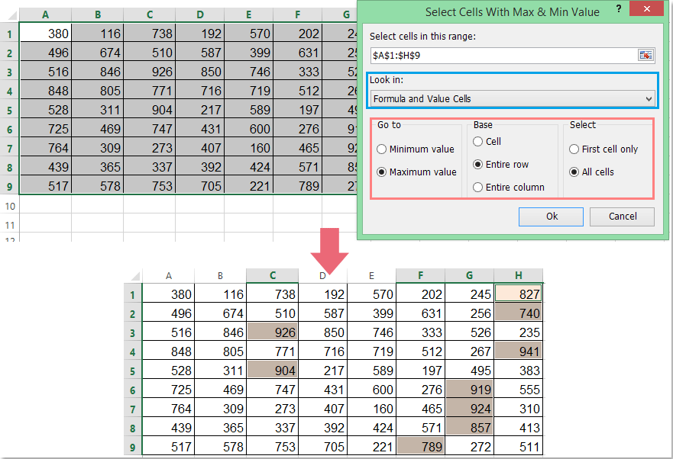
Kutools for Excel: with more than 200 handy Excel add-ins, free to try with no limitation in 60 days. Download and free trial Now!

Highlight Largest / Lowest Value In Each Row Or Column

To make the highest or lowest value standout from each row, please apply the following formula into the Conditional Formatting.
1. Select the data range that you want to highlight the largest value in each row.
2. Then click Home > Conditional Formatting > New Rule, see screenshot:
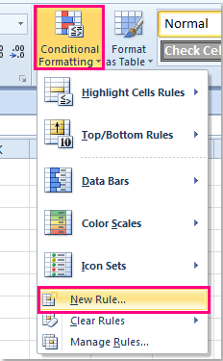
3. In the New Formatting Rule dialog box, click Use a formula to determine which cells to format from Select a Rule Type list box, and then enter this formula =B2=MAX($B2:$E2) into the Format values where this formula is true text box, see screenshot:
Tip: In the above formula, B2 indicates the first cell of your selection, and B2:E2 is the first row range that you want to highlight the largest cell. You can change them to your need.
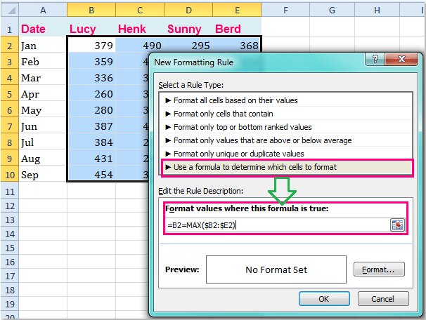
4. Then click Format button, in the Format Cells dialog box, please select one color you like under the Fill tab, see screenshot:
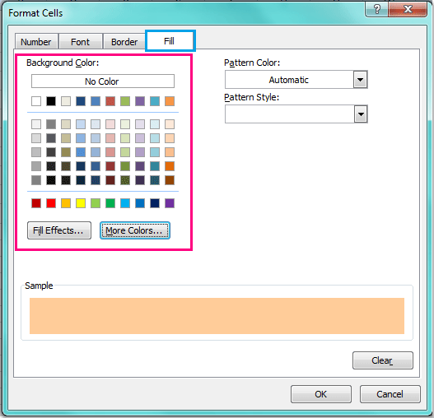
5. And then click OK > OK to close the dialogs, and you will see the largest value has been highlighted in each row.
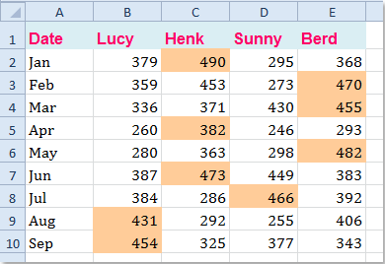
Notes:
1. If you want to highlight the lowest value in each row, you should apply this formula =B2=MIN($B2:$E2) within the Conditional Formatting feature in above step 3.
2. Conditional Formatting tool is a dynamic function, the highlighted color will be adjusted with the changes of your number in your selection.
3. With the Conditional Formatting, you can highlight the largest or lowest value in each column as well. Please enter this formula =B2=MAX(B$2:B$10) or=B2=MIN(B$2:B$10) to highlight the largest or lowest value. (B2 indicates the first cell of your selection, and B2:B10 is the first column range that you want to highlight the largest or lowest value. You can change them to your need.) The below screenshot shows the largest values highlighted in each column:
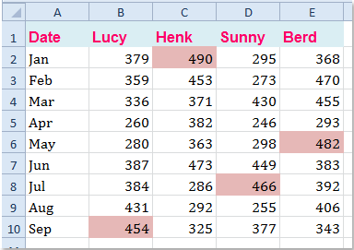

Select Largest / Lowest Value In Each Row Or Column And Shade Them At Once With Kutools For Excel
The first method may be somewhat difficult for our Excel novice, so, here, I can introduce a handy tool – Kutools for Excel, with its Select Cells with Max & Min Value feature, you can quickly select the largest or smallest value of each row or column, and then you can shade them as you need.
Kutools for Excel : with more than 120 handy Excel add-ins, free to try with no limitation in 60 days.
Go to Download
Free Trial 60 daysPurchase
PayPal / MyCommerce
After installing Kutools for Excel, please do as follows:
1. Select the data range that you want to select the largest or smallest value in each row or column.
2. Then click Kutools > Select > Select Cells with Max & Min Value, see screenshot:
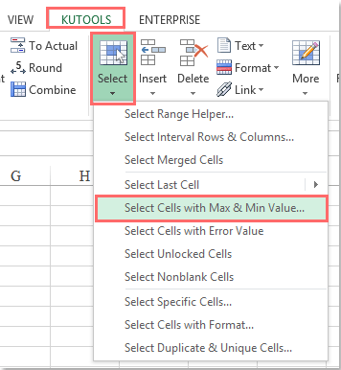
3. In the Select Cells with Max & Min Value dialog box, do the following operations:
- (1.) Choose the type of cells that you want to use under the Look in section, you can select the max or min value from value cells, formula cells or both formula and value cells;
- (2.) Specify the Minimum value or Maximum value that you want to select from the Go to section;
- (3.) Then select the Cell, Entire row or Entire column you want to select the max or min values based on, in this example, I will select Entire row.(Note: If you choose Cell, all the largest or smallest value will be selected in the range, choosing Entire row will select the largest or smallest value in each row, and Entire column will select the largest or smallest value in each column)
- (4.) At last, you can choose First cell only to just select the first matching cell, or All cells to select all the matching cells from the Select section.
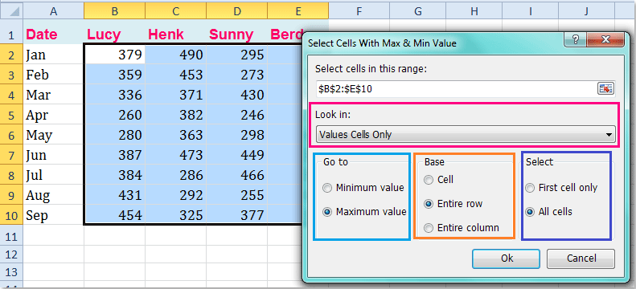
4. And then click OK button, all largest cells have been selected in each row, see screenshot:
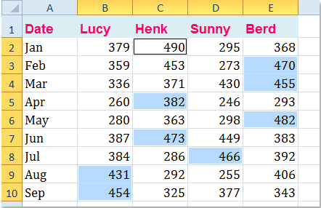
5. Then you can shade them by clicking Home > Fill Color to select one color you like, and all the selected cells are shaded as following screenshot shown:
