How to Create Pivot Table From Multiple Worksheets
Having all data available on a single Worksheet makes it really easy to Create Pivot Tables. However, it may not always be possible to keep all data on single Excel Worksheet and you may be required to Create Pivot Tables using data from

Create Pivot Table From Multiple Worksheets
In order to try an example of Creating Pivot Table using multiple data sources, let us take the case of Sales data from two stores (Store#1 and Store#2) where the data is located on two separate Excel Worksheets.
The task is to use these two separate Worksheets as data sources for the Pivot Table that we are going to create in this example.
1. Choose a Worksheet where you want to generate the Pivot Table. It is best to choose a new Worksheet to generate Pivot Tables, so as to keep things simple and organized.
2. Click on any blank cell in the new Worksheet.
3. Next, Press ALT+D and then P to start the PivotTable and PivotChart Wizard (See image below)
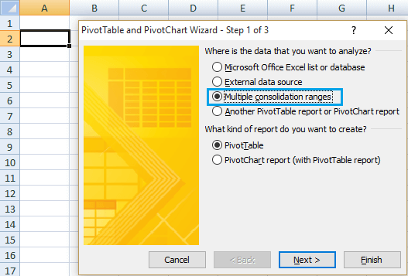

4. Select Multiple Consolidation ranges, and click Next. 5. On the next section of the Pivot Table Wizard, select “I will create the page
filelds” and click Next.
6. Now, select the first data range for the Pivot Table by pointing to the cells in the spreadsheet where sales data for Store#1 is located, and click Add.
7. Select the second data range by pointing to data location on the second Excel Spreadsheet where Sales Data for Store#2 is located, and click Add (See image below)
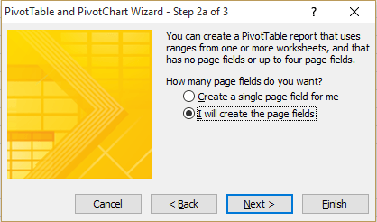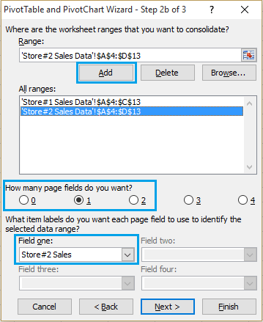

8. Select “1” as the number of Page fields. (See image above)
7. In section labelled “All ranges” select the first data range and give it a label in Field One section. You can call it Store#1 Sales or anything that makes it easy to identify this data range on the pivot table.
8. Likewise, select the next data range and also give it a name. We will call it Store#2 Sales. (See image above)
9. Click Next to move to the third and final section of the Pivot Table Wizard. 10. Finally click on Finish to generate a Pivot Table using the two data sources, stored on two separate Microsoft Excel Worksheets.
Format the Pivot Table
The default raw Pivot Table as generated by Excel after Step#10 (above) may not really make much sense to you. You need to format the Pivot Table in order to make it meaningful and presentable to your audience.
Use Pivot Table Options and Pivot Table Field List to manipulate the data fields and make the Pivot Table suit your requirements. You can access Pivot Table Options from the top menu bar by clicking on the Options Tab.
You can access Pivot Table Field List by clicking on anywhere within the pivot table. (See image below)
Tip: You need to play with the Pivot Table Field List to see what it does and how you can manipulate and modify the data in Pivot Table.
Just go ahead and try all options, drag fields around and see what happens. This is the only way to get comfortable with Pivot Tables and master them.
Add Pivot Table Wizard to Quick Access Menu
While you can always access the pivot table wizard by clicking on ALT+D and P, you may find it more convenient to make Pivot Table Wizard as a part of your quick access Tool bar.
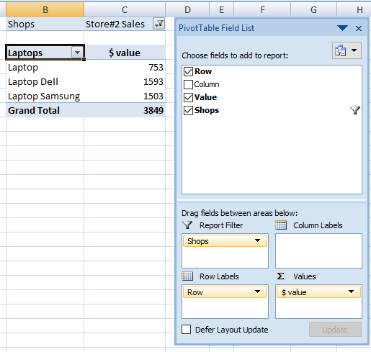

Follow these steps to add Pivot Table Wizard to your quick access menu bar.
1. Click the arrow next to the toolbar and then click More Commands (See image below)
2. On the next screen select “All Commands” under the section Choose commands from. (See image below)
3. From the list of All Commands, select PivotTable and PivotChart Wizard, and click Add.
4. Click OK to add PivotTable and PivotChart Wizard icon to the Quick Access Toolbar. (See image below)
Next time, you can just click on the PivotTable and PivotChart Wizard icon in the Quick Access Toolbar area to quickly launch the Pivot Table wizard, instead of remembering to press ALT+D, followed by P.
