5 tips for selling on Marketplace

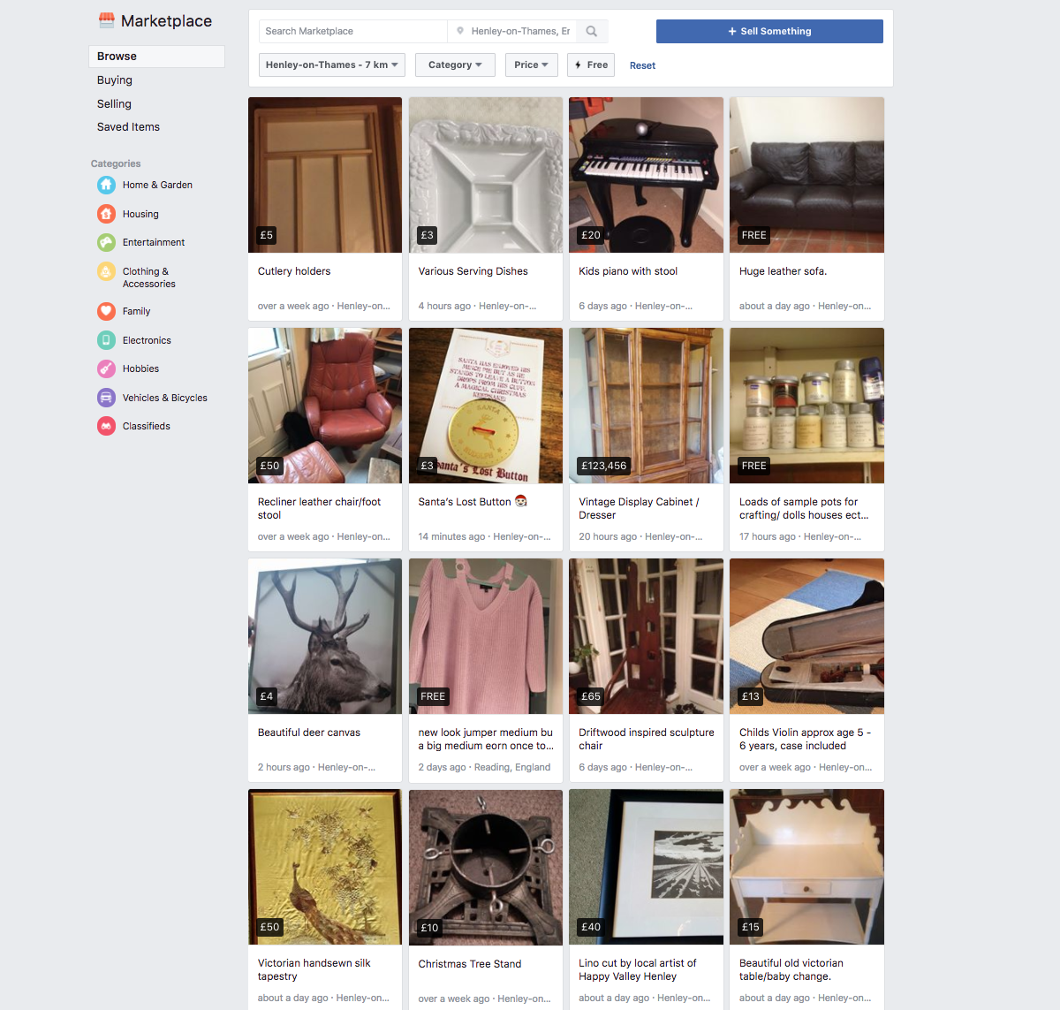

Facebook wants to get into the local buying-and-selling game with its new mobile classifieds section, Facebook Marketplace. The new Facebook Marketplace -- not to be confused with the old Facebook Marketplace -- lets you put up Gumtree-like ads for everything from furniture and clothing to cars and housing. The new Facebook Marketplace lets you sell to anyone (well, anyone within 100 miles of you), rather than limiting you to friends or group members.
Facebook Marketplace is similar to Gumtree: It's a venue, not a facilitator, and the details of any sales (including price, shipping and other logistics) are between the buyer and the seller. Facebook doesn't take a cut of the profits, nor does it offer protection for either party -- like Ebay does -- but it is slightly more credible than Gumtree because it's linked to your Facebook account.
Looking to offload your old sofa or a pile of baby clothes? Here's how to get the most for your stuff.
Tips for better photos
Enlarge Image
Facebook Marketplace is a photo-stream of items for sale, so your first picture needs to be eye-catching -- or, at the very least, well-lit and in focus. Your pictures don't need to be professional -- it's a mobile app, after all -- but it's worth it to spend some time getting the right ones. Here are some tips:
- Keep background clutter to a minimum.
- If you don't have good lighting in your house (you probably don't), go outside and use natural lighting.
- Clean up your item before shooting; wipe fingerprints off screens or electronics.
- Try to get the entire item in the frame for the primary shot (additional shots can be detail shots).
- Take at least three (or more) photos from different angles (Facebook Marketplace lets you add up to 10 photos per listing).
- Use your own photos, not stock photos -- people want to see what the item looks like, and your listing will appear more authentic.

Price high, and prepare for negotiation
You want to get the most for your stuff, but you don't want to alienate people with outrageous prices. To get a ballpark figure for how you should be pricing your items, check completed listings on Ebay -- you may not get quite as much for your stuff (Ebay offers more protection for the buyer, thus buyers are often willing to pay more upfront), but this will give you an idea of where you should start your listing.
Price your item at the high end, but be open to negotiation. Nobody will pay you more than the listed price, but plenty of people will try to negotiate via Facebook Marketplace's Make Offer button (or via private message).

List each item separately
Maybe you're moving and you have a slew of items to post. You might be tempted to combine them all in one mega-moving-sale listing, but if you can spare the extra minutes, you should list each item you're selling separately. Because Facebook Marketplace is primarily picture-based, you only get one picture to capture the heart of your potential buyers -- they're not going to swipe through 10 photos just to see if you have the pieces they want. All of your listings are associated with your Facebook account, so just mention that you're having a moving sale and potential buyers can browse through your listings.

Prep your profile
The big difference between Gumtree and Facebook Marketplace is the fact that Facebook Marketplace is linked to your Facebook profile. This makes Facebook Marketplace a little more credible, because people can see your picture and learn your name (and perhaps other information, depending on what you choose to share) instead of making a completely blind purchase.
What this means is that you want your public profile to make you look like a trustworthy person -- not a scammer. Make sure that your profile picture is a photo of you (preferably a well-lit photo of your smiling face), and that your cover photo is not offensive. Now is also a good time to do a Facebook privacy check -- make sure your public profile isn't sharing information you wouldn't want random strangers to stumble across.

Make the sale
Once you've listed your item and found a potential buyer, it's time to make the sale. Facebook lets you connect with the buyer via Facebook Messenger, and you should use this to hash out all the details -- the condition of the product, the price, the logistics of how the item is going to transfer from seller to buyer, etc. Because Facebook Marketplace does not offer protection for the seller or the buyer, it's important for both of you to be on the same page before any exchanges go down.
Enlarge Image

