Create a PivotChart
Applies To: Excel 2016 Excel 2013 Excel 2010 Excel 2007
It can be hard to see the big picture when you have data in a huge PivotTable or when you have a lot of complex worksheet data that includes text and numbers with column headings, like this:
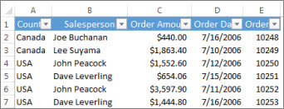
A PivotChart can help you make sense of this data. While a PivotChart shows data series, categories, and chart axes the same way a standard chart does, it also gives you interactive filtering controls right on the chart so you can quickly analyze a subset of your data.
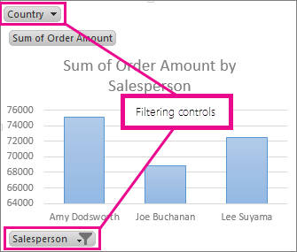
For worksheet data, you can create a PivotChart without creating a PivotTable first. You can even create a PivotChart that is recommended for your data. Excel will then automatically create a coupled PivotTable. Here’s how:
- Click anywhere in the data.
- On the Insert tab, in the Charts group, pick Recommended Charts.
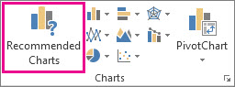
- On the Recommended Charts tab, pick any chart with the PivotChart icon in the top corner. A preview of your PivotChart appears in the Preview pane.
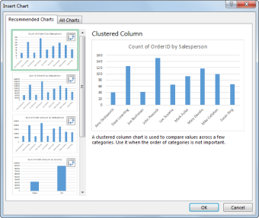
- Once you find the PivotChart you like, click OK.
NOTE: If you don’t find a PivotChart you like, click PivotChart on the Insert tab instead of Recommended Charts.
- In the PivotChart that appears, click any interactive control, and then pick the sort or filtering options you want.
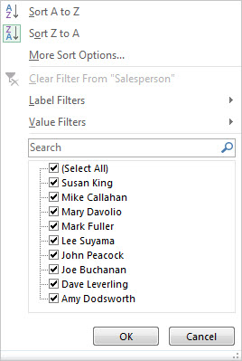
TIP: To remove a PivotChart you no longer want, select it, and then press Delete.

Other ways to create a PivotChart
If you already have a PivotTable, you can base a PivotChart on that PivotTable. Or if you’ve connected to an external Online Analytical Processing (OLAP) or a Data Model data source, you can create a standalone, “de-coupled” PivotChart, without creating a PivotTable at all.
Create a PivotChart for an existing PivotTable
Connect to external data to create a PivotChart
Use an existing external data connection to create a PivotChart

Create a PivotChart for an existing PivotTable
- Click anywhere in the PivotTable to show the PivotTable Tools on the ribbon.
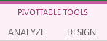
- Click Analyze > PivotChart.
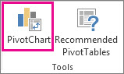
- In the Insert Chart dialog box, click the chart type and chart subtype you want. You can use any chart type except an XY (scatter), bubble, or stock chart.
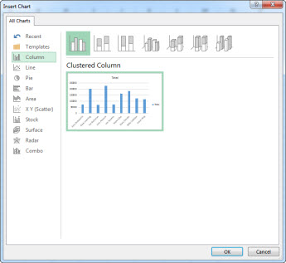
To learn more about the chart types, see Available chart types.
- Click OK.
- In the PivotChart that appears, click any interactive control, and then pick the sort or filtering options you want.
Top of Page

Connect to external data to create a PivotChart
- Click Data > From Other Sources, and then pick the data source you want. For example, pick From Analysis Services to connect to an Online Analytical Processing (OLAP) cube file.
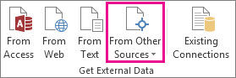
- Follow the steps in the Data Connection Wizard, and click Finish.
- In the Import Data dialog box, pick PivotChart, and the location where you want to put the data, and then click OK.
An empty PivotChart appears and the Field List is shown so you can add or rearrange fields in your PivotChart.
- In the Field List, pick the fields you want to show in the PivotChart.
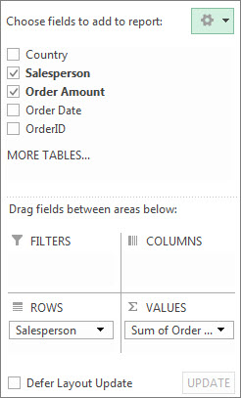
- After you create a PivotChart, you can customize it, much like you’d do with any standard charts. When you select the PivotChart:
- Two buttons appear next to the chart so you can quickly add or change chart elements such as titles or data labels, or change the chart style and colors of your PivotChart the same way you would in a standard chart.
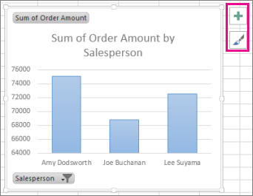
- The PivotChart Tools are shown on the ribbon. On the Analyze, Design, and Format tabs, you can pick options to work with or customize your PivotChart.
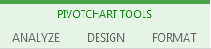
Top of Page

Use an existing external data connection to create a PivotChart
- Click Insert > PivotChart.
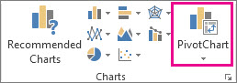
- In the Create a PivotChart dialog box, click Use an external data source, and then click Choose Connection.
- In the Existing Connections dialog box, on the Connections tab, double-click the connection you want.
- Click OK.
An empty PivotChart appears and the Field List is shown so you can add or rearrange fields in your PivotChart.
- In the Field List, pick the fields you want to show in the PivotChart.
- After you create a PivotChart, you can customize it, much like you’d do with any standard charts. When you select the PivotChart:
- Two buttons appear next to the chart so you can quickly add or change chart elements such as titles or data labels, or change the chart style and colors of your PivotChart the same way you would in a standard chart.
- The PivotChart Tools are shown on the ribbon. On the Analyze, Design, and Format tabs, you can pick options to work with or customize your PivotChart.

