Animate text or objects
You can animate the text, pictures, shapes, tables, SmartArt graphics, and other objects in your PowerPoint presentation to give them visual effects, including entrances, exits, changes in size or colour, and even movement. Build a slide presentation that animates bullet points or even production credits.
Animation is a great way to emphasize a point, control information flow, and increase viewer interest. You can apply animation effects on individual slides, the slide master, or custom slide layouts.
4:05
For related information, see Make words appear one line at a time.

Add animation to an object
- Select the object that you want to animate.
An "object" in this context is any thing on a slide, such as a picture, a chart, or a text box. Sizing handles appear around an object when you select it on the slide. (For animation purposes, a paragraph within a text box is also an object, but it won't have sizing handles when you select it; instead the entire text box has sizing handles.)
- On the Animations tab of the ribbon, in the Animation group, click the More button, and then select the animation effect that you want.
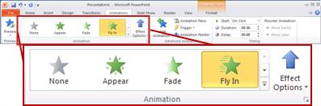
  - If you do not see the entrance, exit, emphasis, or motion path animation affect that you want, click More Entrance Effects, More Emphasis Effects, More Exit Effects, or More Motion Paths.
  - Some entrance and exit effects (such as Flip, Drop, and Whip) and some emphasis effects (such as Brush Colour and Wave) are available only for objects that contain text. If you want to apply an animation effect that isn't available for this reason, try adding a space inside your object.
  - After you have applied an animation to an object or text, the animated items are labeled on the slide with a non-printing numbered tag, displayed near the text or object. The tag appears only in Normal view when the Animations tab is selected or the Animation task pane is visible.

Change the speed of the animation effect
The speed of the effect is determined by the Duration setting.
- On the slide, select the animation effect that you want to change.
- On the Animations tab, under Timing options, in the Duration box, enter the number seconds that you want the animation effect to last.
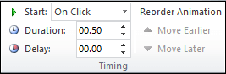
(Maximum: 59 seconds. Minimum: .01 seconds. You can type a duration or use the up or down arrows to select a standard incremental value.)

Change how the animation effect starts
- On the slide, select the animation effect that you want to change.
- On the Animations tab, under Timing options, open the Start list, and choose one of the three options described below:
To start the animation effect | Select
When you click the slide | On Click
At the same time as the previous animation effect in the list. (One click starts two or more animation effects at the same time.) | With Previous
Immediately after the previous animation effect in the list finishes playing. (No additional click is required to make this animation effect start.) | After Previous
- 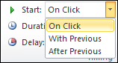

Set the time between animation effects
The Delay option determines how much time elapses before a specific animation effect begins—either after you click or after a prior animation effect concludes.

Change the order of the animation effects on a slide
To reorder a set of animations on a slide:
- Open the Animation pane: On the Animations tab, in the Advanced Animation group, select Animation Pane.
- In the Animation pane, select the animation effect that you want to reorder.
- On the Animations tab of the ribbon, in the Timing group, under Reorder Animation select one of these options:
  - Select Move Earlier to move the effect up one place in the animation order.
  - Select Move Later to move the effect down one place in the animation order.
You can select an option multiple times, if necessary, to move your selected effect to the appropriate place in the animation order.

Remove an animation effect
When you animate an object (such as a bullet point or a picture), a small numeral appears just to the left of that object. This numeral indicates the presence of an animation effect and its place in the sequence of animations on the current slide.
To remove an animation
- Select the numeral of the animation that you want to remove.
- Press the Delete key on your keyboard.

Apply multiple animation effects to a single object
- Select the text or object that you want to add multiple animations.
- On the Animations tab, in the Advanced Animation group, click Add Animation.
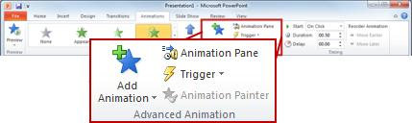

View a list of animations currently on the slide
You can view the list of all the animations on the slide in the Animation Pane. The Animation Pane shows important information about an animation effect, such as the type of effect, the order of multiple effects in relation to one another, the name of the object affected, and the duration of the effect.
To open the Animation task pane, on the Animations tab, in the Advanced Animation group, click Animation Pane.
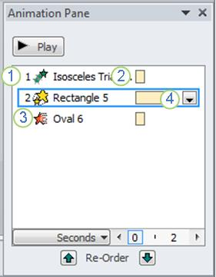
1. In the task pane, numbers indicate the order in which the animation effects play. The numbers in the task pane correspond to the non-printing numbered tags that are displayed on the slide.
2. Timelines represent the duration of the effects.
3. Icons represent the type of animation effect. In this example, it is an Exit effect.
4. Select an item in the list to see the menu icon (down arrow), and then click the icon to reveal the menu.
NOTES:
- Effects appear in the Animation task pane in the order that you add them.
- You can also view the icons that indicate the start timing of the animation effects in relation to the other events on the slide. To view the start timing icons for all animations, click the menu icon next to an animation effect and select Hide Advanced Timeline.
- There are several types of icons that indicate the start timing of animation effects. Choices include the following:
  - Start On Click (mouse icon, shown here): The animation begins when you click the mouse.
  - Start With Previous (no icon): The animation effect starts playing at the same time as the previous effect in the list. This setting combines multiple effects at the same time.
  - Start After Previous (clock icon): The animation effect begins immediately after the previous effect in the list finishes playing.

Set the effect options, timing, or order for an animation
- To set the effect options for an animation, on the Animations tab, in the Animation group, click the arrow to the right of Effect Options and click the option that you want.
- You can specify the start, duration, or delay timing for an animation on the Animations tab.
  - To set the start timing for an animation, in the Timing group, click the arrow to the right of the Startmenu and select the timing that you want.
  - To set the duration of how long the animation will run, in the Timing group, enter the number of seconds that you want in the Duration box.
  - To set a delay before the animation begins, in the Timing group, enter the number of seconds that you want in the Delay box.
- To reorder an animation in the list, in the Animation task pane, select the animation that you want to reorder, and on the Animations tab, in the Timing group, under Reorder Animation, either select Move Earlier to make the animation occur before another animation in the list or select Move Later to make the animation occur after another animation in the list.

Test your animation effect
After you add one or more animation effects, to validate that they work, do the following:
- On the Animations tab, in the Preview group, click Preview.
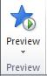

More about animating text and objects
There are four different types of animation effects:
- Entrance effects make an object fade gradually into focus, fly onto the slide from an edge, or bounce into view.
- Exit effects include making an object fly off of the slide, disappear from view, or spiral off of the slide.
- Emphasis effects include making an object shrink or grow in size, change colour, or spin on its center.
- You can use Motion Paths to make an object move up or down, left or right, or in a star or circular pattern (among other effects). You also can draw your own motion path.
You can use any animation by itself, or combine multiple effects. For instance, to make a line of text fly in while it grows, apply a Fly In entrance effect and a Grow/Shrink emphasis effect to it. Click Add Animation to add effects, and use the Animation Pane to set the emphasis effect to occur With Previous.
The gallery of animation effects on the Animations tab shows only the most popular effects. Get even more possibilities by clicking Add Animation, scrolling down, and clicking More Entrance Effects, More Emphasis Effects, More Exit Effects, or More Motion Paths.
