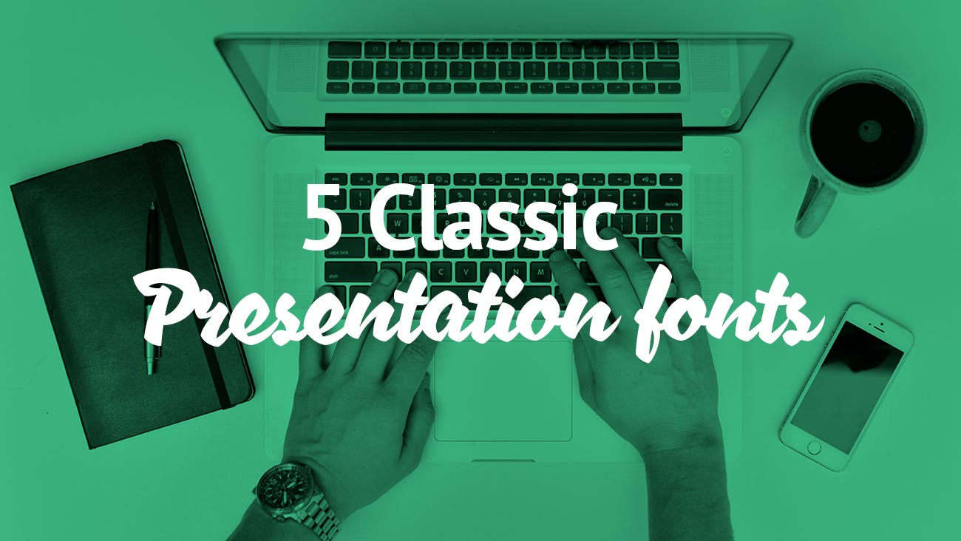

5 Classic Presentation Fonts
Every computer comes with a set of fonts pre-installed as standard. What you probably didn’t know is that some of those fonts totally rock for presentations!
I’ve listed my ‘classic’ go to fonts that I primarily use in my presentation designs. I use these fonts when custom fonts can’t be considered for compatibility reasons using presentation templates over multiple computers. What, pray tell, are these classic fonts I refer to then?
Without further hesitation here are my 5 classic presentation fonts that will look good in any presentation, if you know how to use them correctly!

1. Helvetica
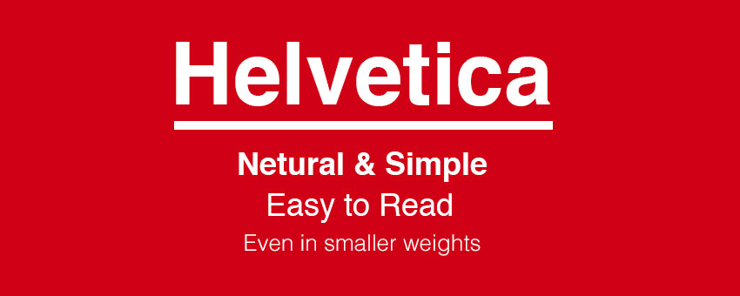
Quick, somebody get the Helvetica police! Sure, you’ve probably heard it recommended time and time again, but frankly I don’t care. Helvetica rocks this world. It is a flexible, diverse and robust typeface.
The beauty of Helvetica is in its neutrality. It is a font that can blend to any style, almost like that a chameleon in the font world.
If I could summarise Helvetica in one sentence, it would be: “Clarity with complete simplicity.”
Helvetica was designed and created by Max Miedinger & Eduard Hoffmann in the late 1950s. Interestingly, Helvetica was originally named Die Neue Haas Grotesk (I’m sure that name went down well with the cool kids).
Helvetica has been extremely popular typeface with corporations. America Apparel, for example, uses it for their logo. Here are 40 Excellent Logos that use Helvetica.
In presentations, Helvetica is powerful and can add real impact, but it doesn’t take over the limelight. It is also really easy to read at different sizes and weights.
Some people may confuse Arial with Helvetica due to their number of similarities. To the non-typography connoisseur’s eye, it is hard to tell the difference between the two. I found an excellent comparison of the two typefaces for you to compare. Personally, I’m also a big fan of Arial, but it didn’t quite make this top 5 list. (Plus, I would have been shot down by a few of my designer buddies of mine had I selected Arial above others on this list.)

2. Garamond

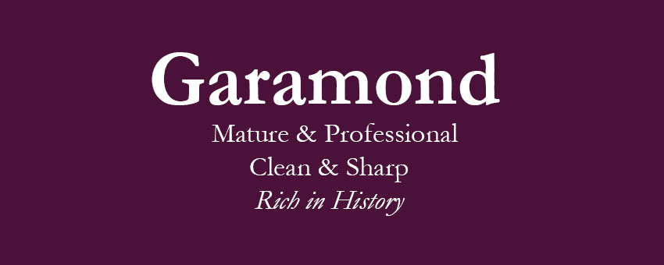
Not a typeface many would automatically go for but a great font all the same. I like Garamond for its more mature qualities.
It is a typeface that always remains professional with quite a clean, sharp appearance.
Garamond has a rich history behind it and one of the reasons I love it! Claude Garamond, a French publisher from Paris, created the font and was one of leading type designers of his time.
The original typeface created for a French King called Francis I in the 1540’s.
There have been many later versions of Garamond created, including numerous variations (trying to improve on the original version) such as a custom variant of the ITC Garamond typeface, called Apple Garamond.

3. Futura
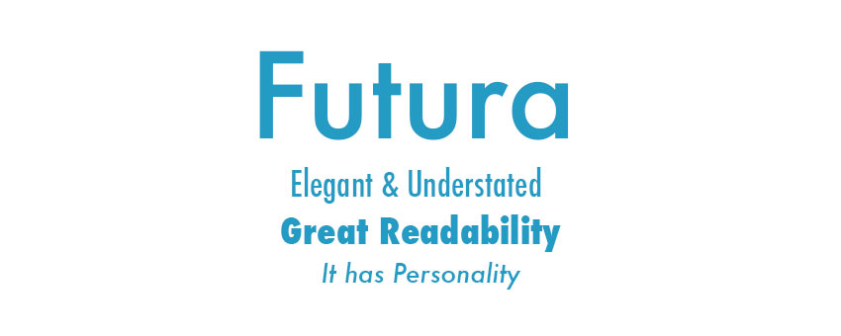
Futura is a Sans-serif typeface (meaning it has no serifs), designed between 1924 and 1926 by typeface designer Paul Renner. Created during the Bauhaus period, commissioned by the Bauer type foundry.
A fun fact for you: the Apollo 11 astronauts left a commemorative plaque on the moon in 1969. The text set in Futura.
Futura is another font that is great for readability and one of the reasons I’m fond of using it in presentations. It is an elegant font that has a real personality.
If you’re using it in presentations is it especially good for headlines. There is an excellent article on Futura’s amazing past to see how the typeface has changed in design over the years.

4. Gill Sans
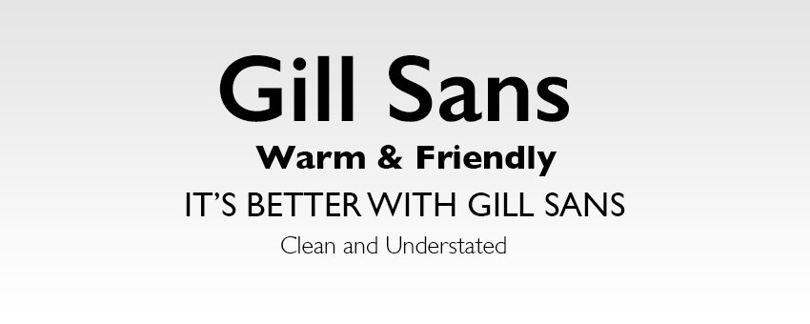
I’ve always had a soft spot for Gill Sans. It used to be my go to font during my school years. I used it in my essays, projects, or just for general homework headings and then let Times Roman do the grunt body text.
Another Sans Serif font, Gill Sans presents a friendly and warm look without being too overstated. Some have even been known to refer to Gill Sans as ‘the British Helvetica’.
Gill Sans created by British graphic artist and sculptor Eric Gill. Initially, it had been inspired by the typeface Johnston, by Edward Johnston. The Johnston typeface had previously been used for Transport for London on the London Underground in 1913. Eric Gill had previously been Johnston’s apprentice at the time.
Gill Sans was popularised during its use as the typeface for all LNER’s (London and North Eastern Railway) posters and publicity material in the late 1920s.
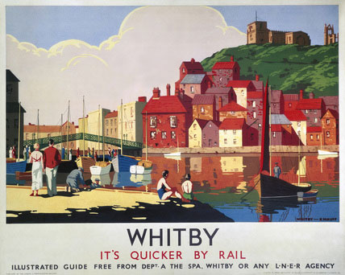
Gill Sans – Beyond classic!
The BBC logo still uses the typeface to this day, and it is still a very modern font with many designers around the world.

5. Rockwell
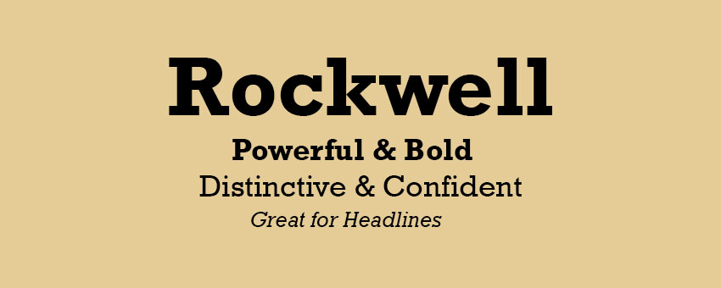
Last but not least, one of my most favourite fonts of all time is Rockwell. The typeface was designed at Monotype foundry’s in-house design studio in 1934.
Rockwell is a font that is bold and vigorous, and it will give your presentation a distinct, confident look about it.
Rockwell primary use should be for display because of its mono-weighted stroke.
I’m a big fan of using Rockwell for the major points and headline text. It can add impact to your design if used right. I’d suggest further reading this article on exploring the use of Rockwell.
There you have it, five classic presentation fonts that every single person who has ever designed an Apple Keynote or Microsoft PowerPoint™ presentation should have in their arsenal. Go out and enjoy them.

